Chapter 4, Problem 17.

Use superposition to obtain v_{x} in the circuit of Fig. 4.85. Check your result using PSpice.

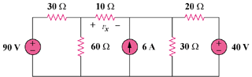

Figure 4.85
For Prob. 4.17.

